**Morning Prayer - March 9, 2025**

**The First Sunday in Lent**

Jesus said, “If anyone would come after me, let him deny himself and take up his cross and follow me.” Mark 8:34

**Opening Hymn “The glory of these forty days” Hymnal #143**

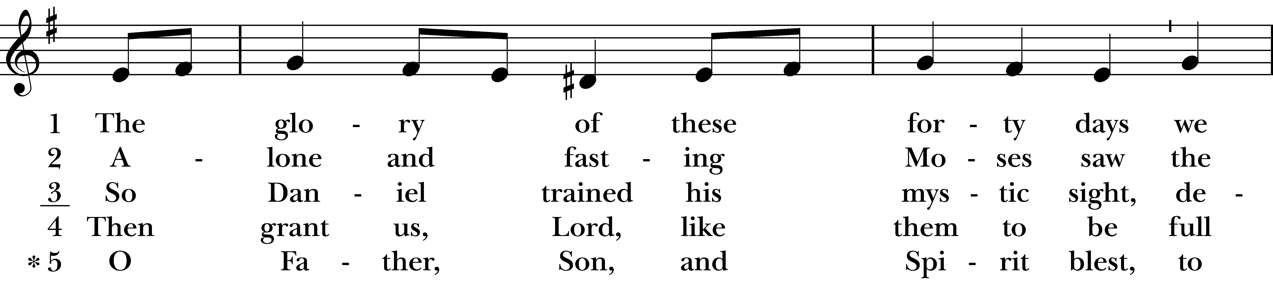  
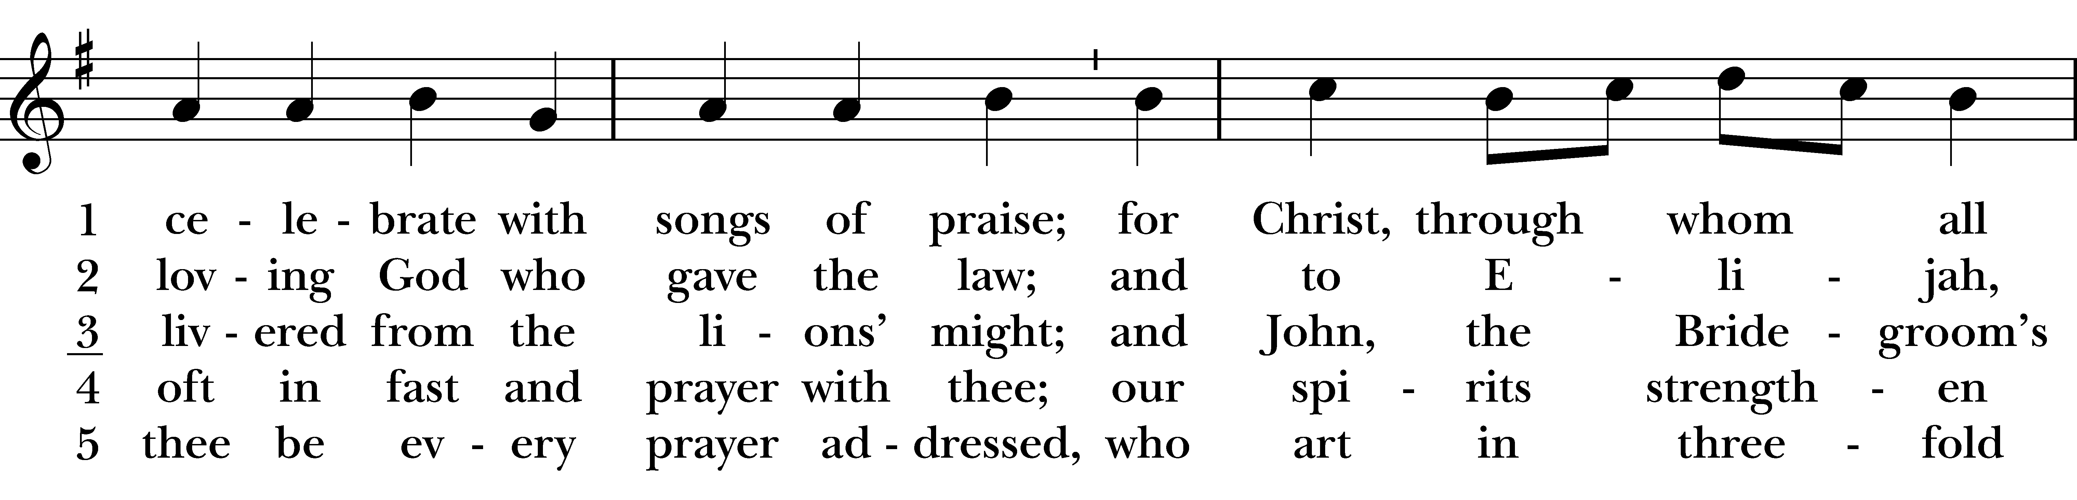  
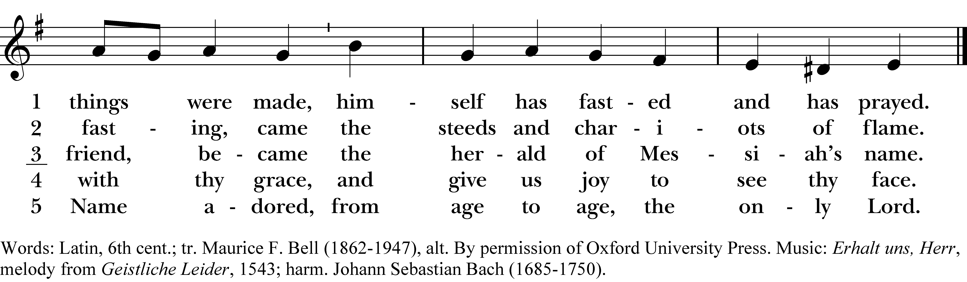

**Confession of Sin**

Dearly beloved, we have come together in the presence of Almighty God our heavenly Father, to set forth his praise, to hear his holy Word, and to ask, for ourselves and on behalf of others, those things that are necessary for our life and our salvation. And so that we may prepare ourselves in heart and mind to worship him, let us kneel in silence, and with penitent and obedient hearts confess our sins, that we may obtain forgiveness by his infinite goodness and mercy. *Silence may be kept. Officiant and People together, all kneeling:*

Most merciful God,  
we confess that we have sinned against you  
in thought, word, and deed,  
by what we have done,  
and by what we have left undone.  
We have not loved you with our whole heart;  
we have not loved our neighbors as ourselves.  
We are truly sorry and we humbly repent.  
For the sake of your Son Jesus Christ,  
have mercy on us and forgive us;  
that we may delight in your will,  
and walk in your ways,  
to the glory of your Name. **Amen.**

Almighty God have mercy on us, forgive us all our sins through our Lord Jesus Christ, strengthen us in all goodness, and by the power of the Holy Spirit keep us in eternal life. Amen.

**Invitatory and Psalter *All stand* BCP p. 80**

Officiant Lord, open our lips.  
People And our mouth shall proclaim your praise.

**Glory to the Father, and to the Son, and to the Holy Spirit:**

**as it was in the beginning, is now, and will be for ever. Amen.**

### Venite Psalm 95:1-7

Come, let us sing to the Lord; *  
**let us shout for joy to the Rock of our salvation.**

Let us come before his presence with thanksgiving *  
**and raise a loud shout to him with psalms.**

For the Lord is a great God, *  
**and a great King above all gods.**

In his hand are the caverns of the earth, *  
**and the heights of the hills are his also.**

The sea is his, for he made it, *  
**and his hands have molded the dry land.**

Come, let us bow down, and bend the knee, *  
**and kneel before the Lord our Maker.**

For he is our God, and we are the people of his pasture and the sheep of his hand. *  
**Oh, that today you would hearken to his voice!**

**Psalm 91:1-2, 9-16 *Qui habitat***

1 He who dwells in the shelter of the Most High, *  
**abides under the shadow of the Almighty.**

2 He shall say to the Lord,  
"You are my refuge and my stronghold, *  
**my God in whom I put my trust."**

9 Because you have made the Lord your refuge, *  
**and the Most High your habitation,**

10 There shall no evil happen to you, *  
**neither shall any plague come near your dwelling.**

11 For he shall give his angels charge over you, *  
**to keep you in all your ways.**

12 They shall bear you in their hands, *  
**lest you dash your foot against a stone.**

13 You shall tread upon the lion and adder; *  
**you shall trample the young lion and the serpent under your feet.**

14 Because he is bound to me in love,  
therefore will I deliver him; *  
**I will protect him, because he knows my Name.**

15 He shall call upon me, and I will answer him; *  
**I am with him in trouble;**  
**I will rescue him and bring him to honor.**

16 With long life will I satisfy him, *  
**and show him my salvation.**

### The First Lesson Deut. 8:1-10

A Reading from the Book of Deuteronomy.

This entire commandment that I command you today you must diligently observe, so that you may live and increase, and go in and occupy the land that the LORD promised on oath to your ancestors. Remember the long way that the LORD your God has led you these forty years in the wilderness, in order to humble you, testing you to know what was in your heart, whether or not you would keep his commandments. He humbled you by letting you hunger, then by feeding you with manna, with which neither you nor your ancestors were acquainted, in order to make you understand that one does not live by bread alone, but by every word that comes from the mouth of the LORD. The clothes on your back did not wear out and your feet did not swell these forty years. Know then in your heart that as a parent disciplines a child so the LORD your God disciplines you. Therefore keep the commandments of the LORD your God, by walking in his ways and by fearing him. For the LORD your God is bringing you into a good land, a land with flowing streams, with springs and underground waters welling up in valleys and hills, a land of wheat and barley, of vines and fig trees and pomegranates, a land of olive trees and honey, a land where you may eat bread without scarcity, where you will lack nothing, a land whose stones are iron and from whose hills you may mine copper.

You shall eat your fill and bless the LORD your God for the good land that he has given you.

The Word of the Lord.  
Thanks be to God.

### The Second Lesson Romans 10:8b-13

A Reading from the Letter to the Romans.

“The word is near you, on your lips and in your heart”

(that is, the word of faith that we proclaim); because if you confess with your lips that Jesus is Lord and believe in your heart that God raised him from the dead, you will be saved. For one believes with the heart and so is justified, and one confesses with the mouth and so is saved. The scripture says, “No one who believes in him will be put to shame.” For there is no distinction between Jew and Greek; the same Lord is Lord of all and is generous to all who call on him. For, “Everyone who calls on the name of the Lord shall be saved.”

**Gospel Hymn “In the Lord I’ll Be Ever Thankful” White pew card**

**The Gospel Luke 4:1-13**

A Reading from the Gospel According to Luke.

After his baptism, Jesus, full of the Holy Spirit, returned from the Jordan and was led by the Spirit in the wilderness, where for forty days he was tempted by the devil. He ate nothing at all during those days, and when they were over, he was famished. The devil said to him, "If you are the Son of God, command this stone to become a loaf of bread." Jesus answered him, "It is written, 'One does not live by bread alone.'"

Then the devil led him up and showed him in an instant all the kingdoms of the world. And the devil said to him, "To you I will give their glory and all this authority; for it has been given over to me, and I give it to anyone I please. If you, then, will worship me, it will all be yours." Jesus answered him, "It is written,

'Worship the Lord your God, and serve only him.’”

Then the devil took him to Jerusalem, and placed him on the pinnacle of the temple, saying to him, “If you are the Son of God, throw yourself down from here, for it is written,

‘He will command his angels concerning you, to protect you,’

and ‘On their hands they will bear you up, so that you will not dash your foot against a stone.’”

Jesus answered him, “It is said, ‘Do not put the Lord your God to the test.’” When the devil had finished every test, he departed from him until an opportune time.

The Word of the Lord.

**Thanks be to God.**

**The Reflection Andy Hathaway**

### The Apostles’ Creed BCP p. 96

I believe in God, the Father almighty,  
 creator of heaven and earth.  
I believe in Jesus Christ, his only Son, our Lord.  
 He was conceived by the power of the Holy Spirit  
 and born of the Virgin Mary.  
 He suffered under Pontius Pilate,  
 was crucified, died, and was buried.   
 He descended to the dead.  
 On the third day he rose again.  
 He ascended into heaven,  
 and is seated at the right hand of the Father.  
 He will come again to judge the living and the dead.  
I believe in the Holy Spirit,  
 the holy catholic Church,  
 the communion of saints,  
 the forgiveness of sins,  
 the resurrection of the body,  
 and the life everlasting. **Amen.**

Announcements and Offering

The Prayers BCP p. 97

Officiant The Lord be with you.  
People And also with you.  
Officiant Let us pray.

**The Lord’s Prayer**

Our Father, who art in heaven, hallowed be thy Name, thy kingdom come, thy will be done, on earth as it is in heaven. Give us this day our daily bread. And forgive us our trespasses, as we forgive those  
who trespass against us. And lead us not into temptation, but deliver us from evil. For thine is the kingdom, and the power, and the glory, for ever and ever. **Amen.**

Suffrages B

V. Save your people, Lord, and bless your inheritance;  
R. Govern and uphold them, now and always.  
V. Day by day we bless you;  
R. We praise your name for ever.  
V. Lord, keep us from all sin today;  
R. Have mercy on us, Lord, have mercy.  
V. Lord, show us your love and mercy;  
R. For we put our trust in you.  
V. In you, Lord, is our hope;  
R. And we shall never hope in vain.

**The Prayers of the People (Form III) BCP p. 387**

Father, we pray for your holy Catholic Church;  
That we all may be one.

Grant that every member of the Church may truly and humbly serve you;  
That your Name may be glorified by all people.

We pray for all bishops, priests, and deacons;  
That they may be faithful ministers of your Word and Sacraments.

We pray for all who govern and hold authority in the nations of the world;  
That there may be justice and peace on the earth.

Give us grace to do your will in all that we undertake;  
That our works may find favor in your sight.

Have compassion on those who suffer from any grief or trouble;  
That they may be delivered from their distress.

Give to the departed eternal rest.  
Let light perpetual shine upon them.

We praise you for your saints who have entered into joy;  
May we also come to share in your heavenly kingdom.

Let us pray for our own needs and those of others, especially those on our **parish prayer list …**  
[Silence]

Heavenly Father, you have promised to hear what we ask in the Name of your Son: Accept and fulfill our petitions, we pray, not as we ask in our ignorance, nor as we deserve in our sinfulness, but as you know and love us in your Son Jesus Christ our Lord. Amen.

**The Collect of the Day**

Almighty God, whose blessed Son was led by the Spirit to be tempted by Satan; Come quickly to help us who are assaulted by many temptations; and, as you know the weaknesses of each of us, let each one find you mighty to save; through Jesus Christ your Son our Lord, who lives and reigns with you and the Holy Spirit, one God, now and for ever. Amen.

**Seasonal Collect for Lent**

Almighty and everlasting God, you hate nothing you have made and forgive the sins of all who are penitent: Create and make in us new and contrite hearts, that we, worthily lamenting our sins and acknowledging our wretchedness, may obtain of you, the God of all mercy, perfect remission and forgiveness; through Jesus Christ our Lord, who lives and reigns with you and the Holy Spirit, one God, for ever and ever. Amen.

**A Prayer of St. Chrysostom BCP p. 102**

Almighty God, you have given us grace at this time with one accord to make our common supplication to you; and you have promised through your well-beloved Son that when two or three are gathered together in his Name you will be in the midst of them: Fulfill now, O Lord, our desires and petitions as may be best for us; granting us in this world knowledge of your truth, and in the age to come life everlasting. Amen.

Closing Hymn “In Christ there is no East or West” Hymnal #529

**Dismissal**

Glory to God whose power, working in us, can do infinitely more than we can ask or imagine: Glory to him from generation to generation in the Church, and in Christ Jesus for ever and ever. Amen. Ephesians 3:20,21

Let us bless the Lord.  
Thanks be to God.

_______________________________________________________________________________________

Announcements for 3/9/25

**COFFEE HOUR: Please consider signing up to host coffee hour. The sign-up sheet is located in the narthex.**

**CONCERTS ON THE HILL – SPONSORS NEEDED: Sponsorship forms are in the narthex. Please distribute to businesses that you frequent and ask that they become a sponsor.**

**PARISH FIELD TRIP TO ESSEX – SATURDAY, MARCH 15th:** Join us for lunch at the Griswold Inn and a special viewing of the St. John Bible with a docent at St. John’s Church in Essex. Carpooling will be available.

**NOURISH BRIDGEPORT – THURSDAY, MARCH 20th:** Let Jim Swann know if you would like to sign up for kitchen duty (3 to 5:30) or service (5:45 to 7).

**VESTRY MEETING – TUESDAY, 3/25:** 7pm on Zoom. All are welcome to attend. Please email Vicki for the Zoom link.

**QUIET DAY at Camp Washington – SATURDAY, 3/29:** Bring your hearts and spirits to a one-day retreat of meditations, music, meal, and sacrament with Rev. Tuesday Rupp and a special musical guest. Register in advance online. (Vicki is going if you want a ride.)

**GIFT CARDS** to gas stations/grocery stores are always needed. Thank you for your continued generosity.

**Upcoming Worship Dates**

**Sunday, 3/16 @ 9:30 am: Eucharist (Rev. Isabel Geller)**

**Sunday, 3/23 @ 9:30 am: Eucharist (Rev. John Branson)**

**Sunday, 3/30 @ 9:30 am: Morning Prayer (Jim Swann)**

**Sunday, 4/6 @ 9:30 am: Eucharist (Rev. John Branson)**

**Christ Church Episcopal: 59 Church Road, Easton, CT 06612**

**Parish Office: 203-268-3569 & christchurcheastonct@gmail.com**

Vicki MarkAnthony, Sr. Warden; Tracy Carlucci, Music Minister

Vestry: Jim Swann, Jr. Warden; Bob Ellwanger, Treasurer; Peg Ellwanger, Clerk

Members: Russ Bailas, Amy Bailas, Marina Philips, Claire Wilkes