**Concerts on the Hill Sponsorship Form - 2025 Season:**

**Sundays June 22, 29, July 6, 13, 20 & 27**

**Payment and form due by: May 1st**

**NAME OF BUSINESS or INDIVIDUAL** (as it should appear on all acknowledgements):

_________________________________________________________________________________________________

**ADDRESS:**_________________________________________________________ **PHONE:** ______________________

**EMAIL:** ___________________________________________ **WEBSITE:** ____________________________________

*For business sponsorships:* Authorized by (please print name): _______________________________________________

**DESCRIPTION of your business’s products/services (for social media posts):** _______________________________

__________________________________________________________________________________________________

**SPONSORSHIP LEVELS & PERKS:**

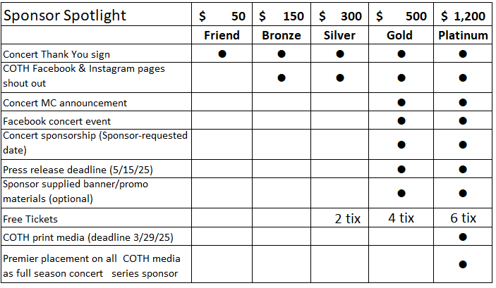

**Indicate Sponsorship Level: ________________ Gold Sponsors: specify concert date: ___________**

**For Silver, Gold & Platinum: do you want your free tickets? YES / NO**

**Instructions:** 1) Email your completed form to [concertsonthehilleaston@gmail.com](mailto:concertsonthehilleaston@gmail.com) 2) Pay online at [www.christchurcheaston.com/give](http://www.christchurcheaston.com/give)

Or mail this form & a check to “Christ Church” (memo “COTH Sponsor”) to: 59 Church Rd, Easton, CT 06612

**All sponsorship payments are a tax-deductible donation to the amount allowable by law.**

*A receipt will be mailed to the address you provide above.*

**About Concerts on the Hill:** Set on the scenic grounds of Christ Church Easton, this outdoor concert series has been a local favorite since its inaugural season in 2017. Gates: 5:30 pm; music: 6:00-8:00 pm. Craft beer/wine, food trucks, or BYOB & picnic! Rain dates TBA. $12 adults, $8 seniors, kids 18 & under free.

**More info:** [www.linktr.ee/concertsonthehilleaston](http://www.linktr.ee/concertsonthehilleaston) | 203-268-3569 | concertsonthehilleaston@gmail.com